Urbanization Occupancy Probability Graphs:

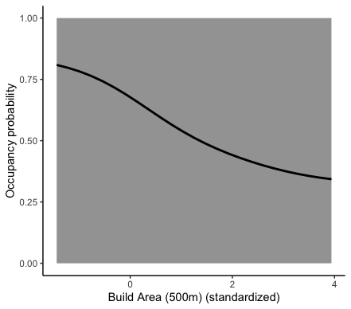

**Figure 1**. Occupancy Probability vs Built Area (500m)

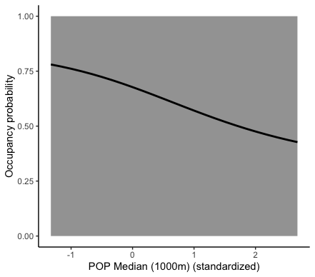

**Figure 2**. Occupancy Probability vs Population Median (1000m)

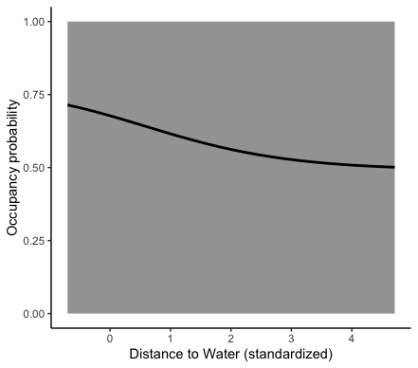

**Figure 3**. Occupancy Probability vs Distance to Water

**Figure 4**. Occupancy Probability vs PA Coniferous Forest (100m)

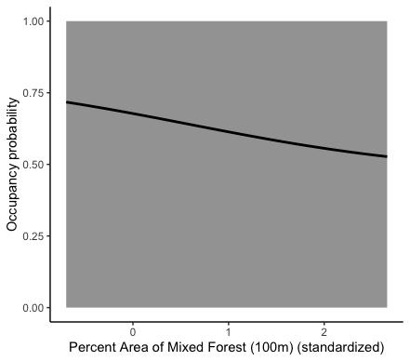

**Figure 5**. Occupancy Probability vs PA Mixed Forest (100m) 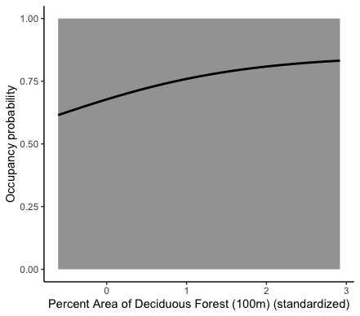

**Figure 6**. Occupancy Probability vs Managed Vegetation(100m)

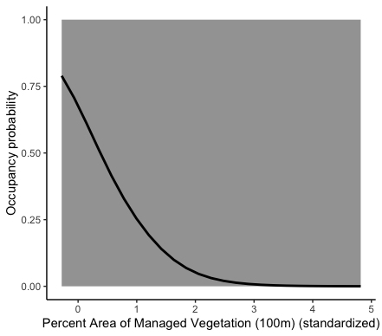

**Figure 7**. Occupancy Probability vs PA Dec. Forest (100m)

**Figure 8**. Occupancy Probability vs PA Dec. Forest (1000m)

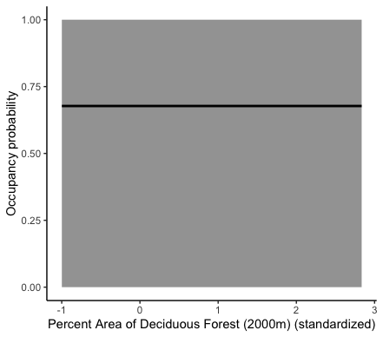

**Figure 9**. Occupancy Probability vs PA Dec. Forest (2000m)